This n That

An e-mail newsletter from Agapé Athletics Club

Editor: Marieta Bortoli 082 466 7031 14 January 2019 www.agape.org.za

E-mail: marietabortoli@gmail.com

NB

- Next league race – 19 January
- Agapé race (Jacaranda City Challenge) – 12 October. Members to assist. PLEASE DIARIZE !!!!!!

Editorial

The 2019 licenses are available. Please visit our website for registrations.

This coming Saturday is the 1st league race of the year. Please attend so that we can start the news season with a bang. Remember to complete your entry slip in full; i.e. name, surname, gender, age and province (AGN).

Our race organizer is already very busy with arrangements for our race as we will most probably move to a new venue and hopefully with a new sponsor on board. Please keep our race in your prayers so that we can present a well-organized race.

Notice Board Additions

◊ Bronkhorstspruit Race
◊ Bestmed Tuks Race
◊

Attachments

□ 2019 AGN Cross Country Fixture
□ Agapé registration form
□ ASA registration form

Birthday Greetings

May your birthday bring joy, contentment and may the Lord’s blessing surround you.

Mag jy in hierdie nuwe lewensjaar ‘n innerlike vrede ken wat jou in staat sal stel om die eise en behoeftes van elke dag in die seker wete van die Heer se teenwoordigheid tegemoet te gaan.

Sharon Eagle 14 January | Elbert Loubser 15 January
De Wet de Beer 17 January | Sharon Urbani 17 January
Anna Maria Roodzant 20 January | Obakeng Pienaar 27 January
Ben Strydom 27 January | Gina Hughes 28 January
Robbie Stutterheim 29 January | Martie Boesenberg 31 January

Personalia

Welcome new and former members

Marike Boudouris Adri Moolman Hugo Moolman

In the mailbox

Comrades 2019
Qualifying for the 2019 Comrades Marathon is applicable as of 26 August 2018 till 2 May 2019. The qualifying criteria for next year’s Comrades Marathon will be to complete a standard 42.2km marathon in under 4 hours and 50 minutes, or a 56km ultra-marathon in under 6 hours and 45 minutes.

The Substitution Process will open on 1 March and close on 15 April 2019, allowing athletes an extra two weeks for potential substitutions. The cost of a Substitution is R300.
The Official Comrades Coach, Lindsey Parry has devised the various training programmes for aspirant #Comrades2019 athletes.
Whether you are aiming for Comrades Gold, Silver, Bronze or something in between, find all you need to know HERE
Coach Parry says, “The Up Run is a huge challenge. It is important to prepare physically for the challenge, and equally important to prepare mentally for the 87km journey from Durban to Pietermaritzburg.”

General
Registration fees 2019:
First member R400,00
Second member/pensioner/student R350,00
Junior (under 19 – copy of ID document required) R100,00
Social member R100,00

The fees include the ASA licence number.

Kindly visit our website: www.agape.org.za for further information.

==

Clothing available:
Buffs @ R100
Ladies skirts @ R200
Second skins @ R220
Age tags @ R30

The items will also be available at races, please visit our gazebo

Congratulations

Congratulations to the following members:
Thank you’s

Race reports/Upcoming race information

Race report feedback Eersterus (ACE), 12 January 2019, 10 km (Elbert Loubser):
Weather not dissimilar to last Saturday. One could argue that there might have been a teensy bit less cloud cover. Whereas A4A had a 06:30 start, with the Eersterus race we are back to the expected Summer race start times of 06:00. Hmmm, my body and mind were well aware of the 30 minutes 'less sleeping time' afforded to it. :-)

The stadium lights greet us, as we approach the Eersterus Soccer stadium from Stormvoël Road. The aroma whiff of Chad's coffee trailer already subtly tugging at the nostrils. Pete (MC) already 'camped out' on the field, music softly filling the air. At 05:30, at the Agape gazebo(s), future race information is shared and then a 'kringetjie' is formed for prayer. We then needed to make our way out to the start cnr of St Joseph Ave and Fred Adams Ave, approximately 700 meters away.

We headed North, via Hans Coverdale Rd W, with some curves in the proximity of Westside Ave (I felt like a Knight on a chess board), before leaving the 'flats' behind and then we began some serious climbing up Tigris Ave. Left into Square Hill Ave, still climbing. A brief respite back towards Tigris Ave. Hans Coverdale Rd N brought us to Helium Ave, with its own collection of hill/incline challenges. A lively band, just before the downhill of Wilberforce Ave lifted the spirit. Lovely downhill stretch down Landsdown Ave, brought us to Hans Coverdale Rd E, back into the 'flats'.

Phew! So, we have once again conquered those hills. Hmmm, do remember though, going past the 5-kilometre board, does not imply that this halfway point, by any means, infers that all the hills are 'done and dusted' yet. :-(

A lovely flat piece on Hans Coverdale Rd E, right turn into St Joseph Ave, 8-kilometre board left in our wake, we headed back on the 'home stretch'.

Thank you, Hennie, and Marix for our home base gazebo(s) and the exquisite cold refreshing water melon.
AGN numbers for 2019 have arrived. Yip, it is time to fill in the forms, as the 2018 licence is only valid until the end of January 2019. :-)

Thank you, ACE, for another well organised race.

PS: Saturday mornings: The 'Pretoria Boeremark', now at Moreleta Street, Silverton. Open from 5:30 to 9:30.

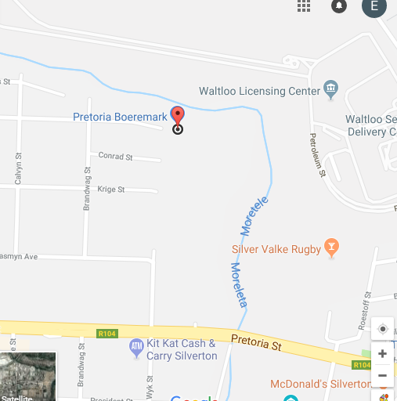 Venue of “Boeremark”
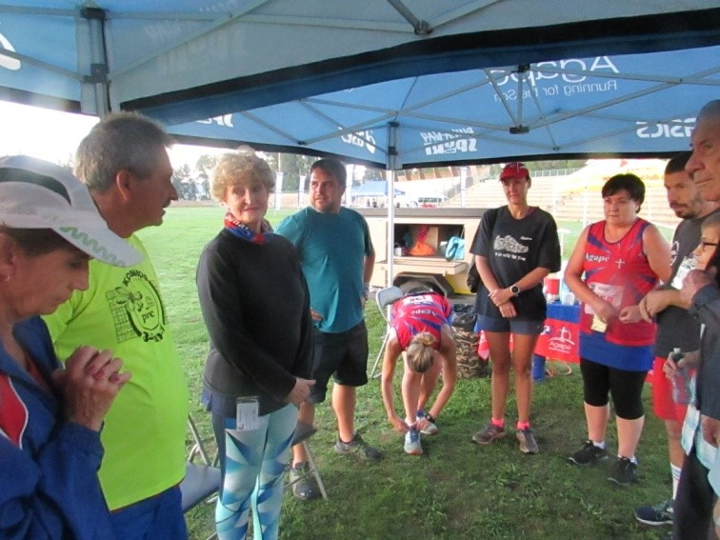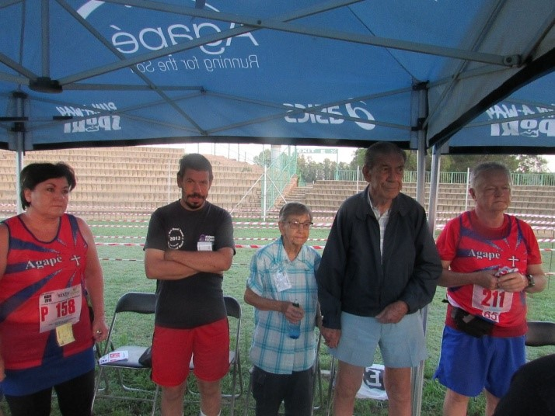

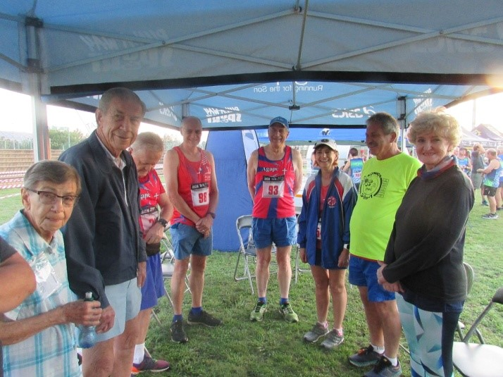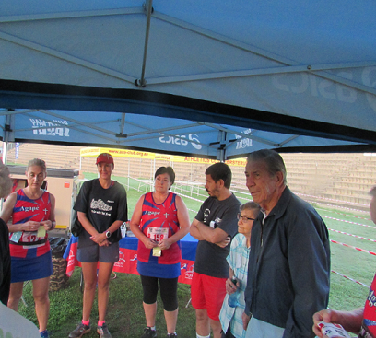

Race Results
A4A Road Safety (AGN) 10km race - 2019-01-05
Position | Initials | Surname | Sex | Age | Finish Time
94 | L | Fourie | M | 74 | 00:57:47
284 | B | Siccnoih | F | 41 | 01:10:46
285 | W | Weder | M | 70 | 01:10:53
353 | J | Barkhuizen | M | 33 | 01:15:03
377 | C | Mouton | F | 62 | 01:16:17
414 | K | V D Merwe | M | 41 | 01:18:13
434 | M | Venter | F | 59 | 01:19:13
436 | H | Venter | M | 59 | 01:19:16
A4A Road Safety (AGN) 21km race - 2019-01-05
Position | Initials | Surname | Sex | Age | Finish Time
49 | K | Imrie | M | 47 | 01:46:41
170 | J | V D Merwe | M | 49 | 02:01:52
219 | M | Atkins | F | 49 | 02:06:39
376 | G | Brink | M | 52 | 02:17:40
541 | L | Fourie | M | 47 | 02:33:19
669 | A | Te Reh | M | 69 | 02:54:40
708 | E | Loubser | M | 61 | 03:14:20

League results

Training/Health snippets

Tips to Prevent Running Injuries
By taking a few precautions and planning, you can prevent many common running injuries. Here are some tips for preventing injuries.
Listen to your body: Don't ignore pain. A little soreness is OK. But if you notice consistent pain in a muscle or joint that doesn't get better with rest, see your health care provider.
Create a running plan: Before beginning a running routine, talk to a trainer. A trainer can help you create a running plan that is in line with your current fitness abilities and long-term goals.
Warm-up and stretch: Many injuries occur as a result of inadequate stretching. Before and after you run, stretch your muscles thoroughly -- especially your calf, hamstrings, groin, and quadriceps.
Also, warm up for five minutes -- by walking, for example -- before you start stretching. Stretching cold muscles may cause injuries.
Strength train: Add weight training and ab exercises to your routine. This strengthens muscles and develops core strength.
Cross train: Mix up your fitness routine. Don't only run. Try swimming, biking, tennis, or some other activity. This helps prevent overuse injuries that more commonly occur when you do the same type of exercise over and over again.
Dress appropriately: Wear lightweight, breathable clothing that wicks moisture away from your skin. Dress in layers. Also wear a hat to protect against the sun and cold.
Be shoe smart: Wear proper-fitting socks and shoes with good support. Remember that running shoes are recommended to last for a certain mileage. If the soles of your running shoes have worn thin or are angled, you over overdue for getting a new pair. If you have foot problems, such as flat feet or high arches, consider using orthotic shoe inserts.
Run wisely: Run on a flat, smooth surface and avoid steep hills until your body gets used to the activity.
Be safe: Run during the day, in well-lit areas, or use a light so that you can be seen. Keep a cell phone and identification on you. If running with headphones, set the volume low enough so that you can hear cars and other noises. Run with a partner when you can.
Weather matters: Monitor the weather conditions before you go for a run. Don't run outside if it is over 90 degrees Fahrenheit, below freezing, or the humidity is high.
Stay hydrated: Make sure you drink an extra 1 1/2 to 2 1/2 cups of water on the days you run. If you are running for more than an hour, drink a sports drink to replenish electrolytes lost in sweat.

Your thought for the week

Be happy for this moment. This moment is your life!

Your smile for the week

Most Friday nights at the naval station in Bermuda, we would assemble at the officer's club after work.
One Friday, Rick, a newly married ensign, insisted he had to leave at 6 p.m.
We all tried to talk him into staying, but he'd promised his bride he'd be home by six. I offered to call home for Rick.
When his wife answered the phone, I said, 'Rick has been kidnapped.
Put five dollars in small, unmarked bills in a plain brown paper bag and throw it in the door of the officer's club.' Then I hung up.
A short time later, a waiter brought a grocery bag to our table.
In it were Rick's baseball glove, a tennis racket, and a teddy bear. Attached to the bear was a note: 'Rick can play kidnapped until 7 p.m. Then he must come home.

Something to ponder over / something spiritual
“Mooi loop" is vir my so n mooi toewensing!
Dit sê.
Kyk tog waar jy gaan
Moenie seerkry nie...
Kyk asb dat ander nie op jou trap nie...
Loop regop en met trots...
Dis ook ‘n sagte boodskap wat sê...
Ek gee baie om...
As jy loop dan sien ek jou weer, want dit klink nie so finaal soos totsiens nie.
Dit sê ook...
Jy het n vriend in my...
Ek dra jou in my hart...
en my gedagtes...
in my gebed... Altyd...
Dit wil vir jou sê...
Jy is spesiaal en uniek
So, Mooi loop
Mag die eerste treë van 2019 doelgerig wees, en die res van jou nuwe jaar vol vrede, voorspoed en geluk.
Mag God se genade ryklik met julle wees
So Mooi loop

Cancelled Races

Notice Board

Useful Links:
www.raceresults.co.za/flyers - for the latest race pamphlets
www.agn.co.za/#League for the latest league logs and the league points you earned
http://www.agn.co.za/Docs/2018/Walking/AGN%20road%20walking%20stds%20ref%20685.pdf
AGN 2017 RW qualifying standards and selection criteria
www.runawaysport.co.za Run-A-Way Sport’s web site
www.verticalhorison.co.za Trail Running www.trailseries.co.za Trail Running
http://www.mastersathletics.net/Age-Graded-Calculator.2595.0.html Age Graded Calculator

League Race
Saturday 19 January PWC George Claassen Memorial Road Race 21.1/10/5 km
Race Organisers: Pretoria Marathon Club
Venue: Pick ‘n Pay Hyper, c/o Atterbury Road & Selikats Causeway, Faerie Glen
GPS: S 25.7841 E 28.3051

 | 21.1 km | 10 km | 5 km
Entry fee | R 90 | R 70 | R 30
Entry fee 70+ & blind runners | Free – race day only
Start Time | 05:30 Walk  06:00 Run |  | 06:15
Cut-off | 03:00

1st 400 online entries receive a dri fit long sleeve shirt

No Pets

Baby strollers welcome on the 5km

Pre-entries at: Run-away Sport; Sweatshop Southdowns, Dunkeld West, Fourways Crossing; Sportmans Warehouse Fourways Crossing, Woodmead, Randburg, Centurion, Kolonnade Centre, Atterbury Value Mart, Menlyn Park

www.enteronline.co.za

Saturday 26 January Wonderpark Road Race 42.2/21.1/10/5 km
Race Organisers: Akasia Athletics Club
Venue: Wonderpark Shopping Centre, c/o Old Brits Road & Heinrich Avenue, Karenpark
GPS: S 25 40,264 E 28 6,703

 | 42.2km | 21.1km |  |  | 10 km | 5 km
Pre-entry fee | R 150 | R 130 |  |  | R 100 | R 50
Entry fees 60+ | R 80 | R 70 |  |  | R 50
Late entry fees (26 & 27 Jan) | R 150 |  | R 130 | R 100
Entry fees 60+ | R 80 |  | R 70 | R 50
Jardine Joggers / 70+ athletes | Free
Start Time | 05:30 |  |  |  | 06:00 | 06:10
Time Limit | 05h:30 |  | 03h00 | 02h30 |  | 01h50

Pre-entries: Run-A-Way Sport, Sweatshop Dunkeld, Bedfordview & Southdowns; Cross Trainer; Total Sports Wonderpark

www.entryrush.co.za & www.akasiaathleticsclub.co.za

Saturday 2 February Intercare Classic Road Race 21.1/10/5 km
Race Organisers: Magnolia Road Runners
Venue: Rietondale Park, North Road, Rietondale
GPS: S 25 43.980 E 28 13.239

 | 21.1 km | 10 km | 5 km
Pre-entry fee | R 130 | R 90 | R 50
Pre-entry fee 60 - 79 | R 60 | R 50 | R 50
Entry fee 1 & 2 February | Closed | R 110 | R 50
Entry fee 1 & 2 February 60 - 79 | Closed | R 50 | R 50
Entry fee 70+ & blind runners | Free
Start Time | 06:00 | 06:20 | 06:25
Cut-off | 03:00 | 02:00 | 01:00
Event t-shirt @ R80 each

1st 1000 on-line entries will receive a goody bag

No Pets

Pre-entries at: Run-away Sport; Sweatshop Southdowns, Dunkeld West, Bedfordview; Sportmans Warehouse Woodmead, Randburg, Centurion, Kolonnade Centre, Atterbury Value Mart

www.intercare.co.za

League Race
Saturday 9 February Bronkhorstspruit Race 32/10/4 km
Race Organisers: Bronkhorstspruit Athletics Club
Venue: Hoërskool Erasmus, Kerk Street, Bronkhorstspruit (take Delmas off ramp)

 | 32 km | 10 km | 4 km
Entry fee | R 150 | R 80 | R 20
Entry fee 60+ | Free
Start Time | 06:00 | 06:15 | 06:30
Cut-off | ??

1st 200 32km entries at Run-Away Sport receive a t-shirt

No Pets

Pre-entries at: Run-away Sport

www.enteronline.co.za
Saturday 16 February Bestmed Tuks Race 42.2/21.1/10/5/1 km
Race Organisers: Tuks Sport
Venue: Hillcrest Sports Campus, Burnett Street, Hatfield
GPS: S 25 44’58” E 28 14’47”

 | 42.1 km | 21.1 km | 10 km | 5km | 1 km
Entry fee | R 200 | R 150 | R 100 | R 50 | R 30
Entry fee 60 - 79 | R 100 | R 75 | R 50
Entry fee 80+ / blind athletes | Free
Start Time | 05:30 | 06:00 | 06:30  Wheelchair  06:20 | 06:40 | 08:00
Cut-off time | 05:30 | 03:00

42.2km race is a pre-entry race only and limited to 4000

No Pets

Only the 10km race is wheelchair friendly

Pre-entries at: Run-away Sport; Sweatshop Southdowns, Dunkeld West, Fourways Crossing; Tshwane Running Shop; UP Hatfield Campus

www.entrytime.com

2019 AGN LEAGUE FIXTURE LIST
EVENT | DISTANCE | DATE | LEAGUE
 |  |  | RR | RW
PWC George Claassen | 21.1/10 km | 19/01/19 | X | X
Bronkhorstpruit | 32/10 km | 09/02/19 | X | X
Medihelp Sunrise Monster | 32/21.1/10 km | 02/03/19 | X | X
Run Against Drugs | 21.1/10 km | 13/04/19 | X | X
Skosana Development Run | 21.1/10 km | 25/05/19 | X | X
Race of Friendship | 21.1/10 km | 29/06/19 | X | X
Zwartkop Road Race | 21.1/10 km | 27/07/19 | X | X
Spirit of Flight | 10 km | 31/08/19 | X | X
Brooklyn Road Race | 21.1/10 km | 07/09/19 | X | X
Capital Classic | 21.1/10 km | 05/10/19 | X | X
Freedom of Expression | 21.1/10 km | 02/11/19 | X | X

Masters Athletics Fixture list

South Africa
? March 2019 KZN Kings Park Stadium
29/30 March 2019 PE Westbourne Oval
29/30 March or 19/20 April 2019 GNMA Pilditch
5/6 April 2019 WP Cape Town
13 April 2019 CGMA Herman Immelman
10 August 2019 Mpumalanga Secunda
? October 2019 Rassies Bronkhorstspruit
25/26 October 2019 SWD Oudtshoorn
8/9 November 2019 Free State Bloemfontein

South African Championships
3/4 May 2019 SWD Oudtshoorn
April/May 2020 Central Gauteng Herman Immelman

Africa Championships
2021 Nairobi, Kenya
2023 South Africa

International Championships
24-30 March 2019 WMA Indoor Torun, Poland
28/9-6/10 2019 30th Summer universiade Naples, Italy
20/7/2020 – 1/8/2020 World Masters athletics Champs Toronto, Canada

Time Trials:

Centurion - Wednesdays at 17:30
Lewende Woord Centurion
Contact Marinda 654 5800 (h) / 082 720 9017

Zita Park - Tuesdays at 17:30
Zita Street, Zita Park, Garsfontein
Contact Hennie Venter – 082 676 6792

Gazebo Enquiries

Hennie Venter – 082 676 6792

Intercessor:



Jaco Barkhuizen 083 519 1737

Agapé Executive 2018/2019

Name | Position | Telephone number | E-mail address
Hennie Venter | Chairperson | 082 676 6792 | henniev@seng.co.za  venterhennie08@gmail.com
Hennie Venter | Registrar | 082 676 6792 | henniev@seng.co.za  venterhennie08@gmail.com
Marieta Bortoli | Treasurer & Vice chairperson | 082 466 7031 | marietabortoli@gmail.com
Marieta Bortoli | Secretary | 082 466 7031 | marietabortoli@gmail.com
Hennie Venter | Club Captain | 082 676 6792 | henniev@seng.co.za  venterhennie08@gmail.com
De Wet de Beer | Race organizer | 082 373 2987 | dewet@styletechnique.co.za
De Wet de Beer | PRO | 082 373 2987 | dewet@styletechnique.co.za
Marieta Bortoli | Editor | 082 466 7031 | marietabortoli@gmail.com
Jaco Barkhuizen | Intercessor | 083 519 1737 | jaco00028@gmail.com
 | Clothing co-ordinator
 | General activities
Gustav Brink | Statistician | 083 417 8431 | gustav.brink@gmail.com

Agapé Executive


Hennie Venter Marieta Bortoli De Wet de Beer


Jaco Barkhuizen Gustav Brink (Ex-officio)

